Business Offices and/or Payroll Centers can provide email lists for their department/college when requested. Both the requestor and the one pulling the list should review the Guidelines for Purdue Email Address and Career Account.

The Employee Listing Standard Report available in Cognos contains email addresses.

Any requests for email lists based on anything other than department/division or employee class should be sent to the HR Data and Analytics team via the HR Data Request form.

Accessing Cognos and Completing Prompts
Access Cognos via OneCampus Portal  Login with BoilerKey. | 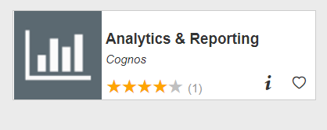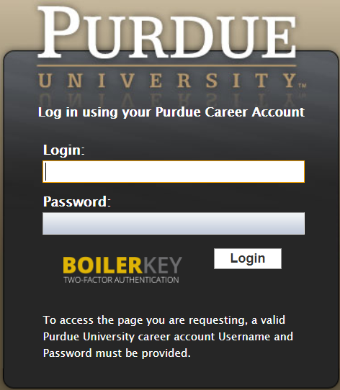
Access the Standard Content Folder within Boiler Insight | 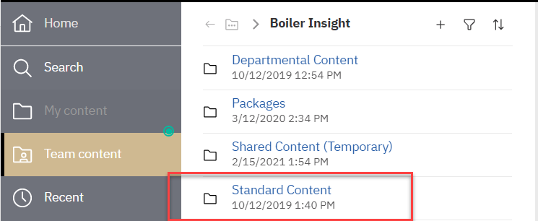
Select Employee Listing with Salary Details from the HR and Payroll folder | 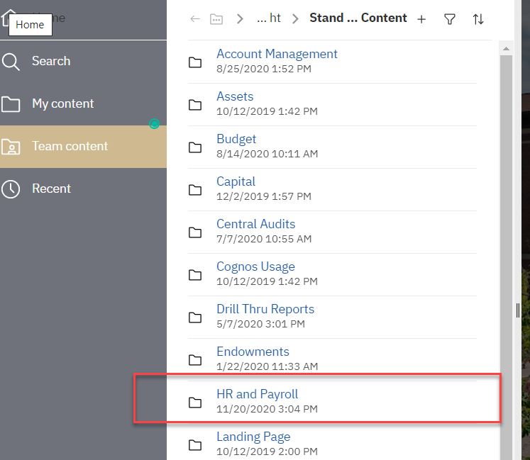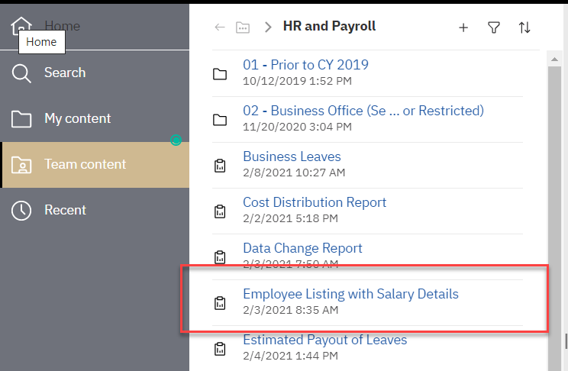
Use the Export Option.
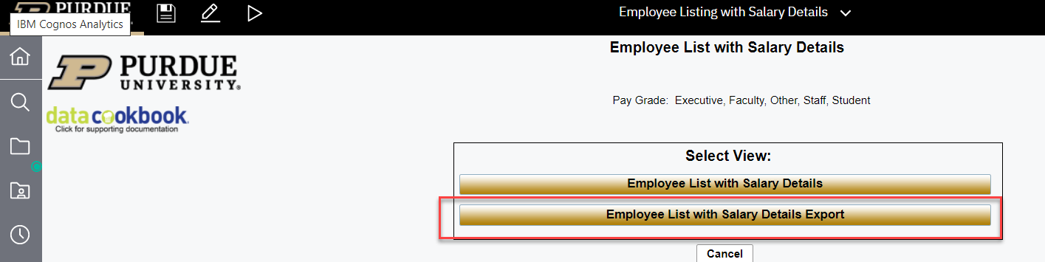

Always use the current Calendar Year-Month selection.
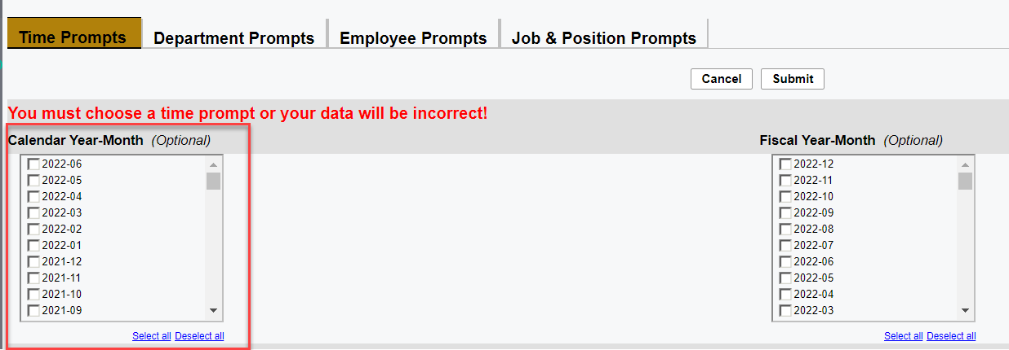

Then, dependent on what the requester is needing, you will use the Department prompts, Employee Prompts or Job and Position prompts accordingly.
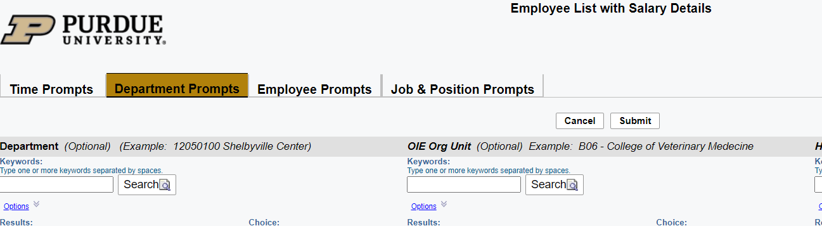

Scroll across the columns to locate the email addresses. In the example below the email addresses are in column AR. Please cut and paste to supply the requester what is needed, without including columns that are not needed. If you experience trouble pulling the email list, contact hroperhelp@purdue.edu.
